PARTICIPANTS NEEDED!!
Digital Tabletop Game Testing

Participants are needed in a study being carried out in the Collaborative Systems Lab, Department of Systems Design Engineering, at the University of Waterloo. The study aims to improve information transfer experiences in a multi-touch display digital game. Participants will play the Dominion card game on a digital tabletop computer. Please allow up to three hours for the study session. Results may contribute to the development of digital tabletop games.

Participants must:  - Be aged 18 and older  - Have some experience  playing Dominion, by  Rio Grande Games  - Sign up in groups of 2 | 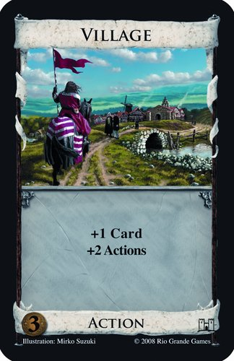

Each participant will be given a $20 honorarium for his/her participation.

If you are interested in being a participant in this study, please contact Nippun Goyal by email at nippun.goyal@uwaterloo.ca

Thanks for your attention!

This project was reviewed and received ethics clearance through the University Of Waterloo Office Of Research Ethics.

Dominion Tabletop Game Study  Contact: Nippun Goyal  nippun.goyal@uwaterloo.ca | Dominion Tabletop Game Study  Contact: Nippun Goyal  nippun.goyal@uwaterloo.ca | Dominion Tabletop Game Study  Contact: Nippun Goyal  nippun.goyal@uwaterloo.ca | Dominion Tabletop Game Study  Contact: Nippun Goyal  nippun.goyal@uwaterloo.ca | Dominion Tabletop Game Study  Contact: Nippun Goyal  nippun.goyal@uwaterloo.ca | Dominion Tabletop Game Study  Contact: Nippun Goyal  nippun.goyal@uwaterloo.ca | Dominion Tabletop Game Study  Contact: Nippun Goyal  nippun.goyal@uwaterloo.ca | Dominion Tabletop Game Study  Contact: Nippun Goyal  nippun.goyal@uwaterloo.ca

